Our split units have two different PCBs, new PCB part number is 0010451167, this PCB can directly install with group controller.
New PCB can directly be installed with group controller
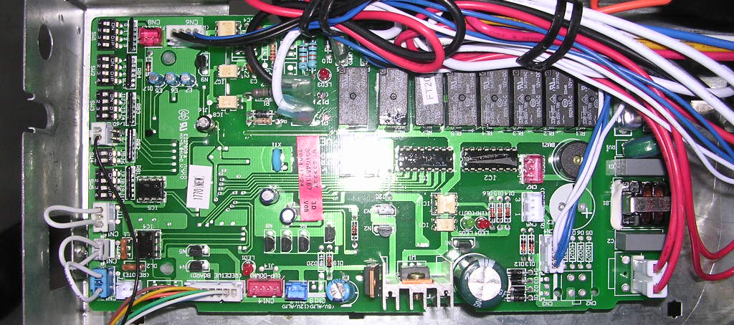
CN16
SW01
SW02

Step 1: connect wire from indoor PCB(CN16 A,B) to group controller(A,B)
Step 2:set address with dip switch SW01 and SW02 .
Dip switch（1- ON，0-OFF） |  |  |  |  |  |  |  | Address number
SW02 |  |  | SW01 |  |  |  |  | Address number
No.3 | No.2 | No.1 |  | No.4 | No.3 | No.2 | No.1 | Address number
0 | 0 | 0 |  | 0 | 0 | 0 | 0 | 1-1
0 | 0 | 0 |  | 0 | 0 | 0 | 1 | 1-2
0 | 0 | 0 |  | 0 | 0 | 1 | 0 | 1-3
0 | 0 | 0 |  | 0 | 0 | 1 | 1 | 1-4
0 | 0 | 0 |  | 0 | 1 | 0 | 0 | 1-5
0 | 0 | 0 |  | 0 | 1 | 0 | 1 | 1-6
……
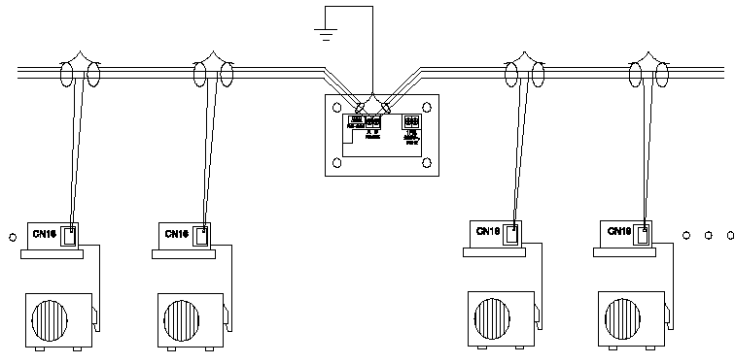
Use one wired controller control several indoor units, do as the following wiring diagram, and set indoor address same with group controller installation.
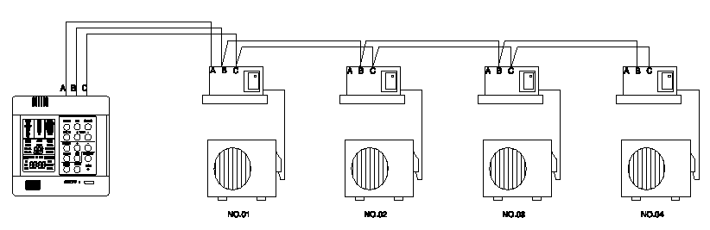
the old PCBs have many different part numbers, and must use detector to connect with group controller.
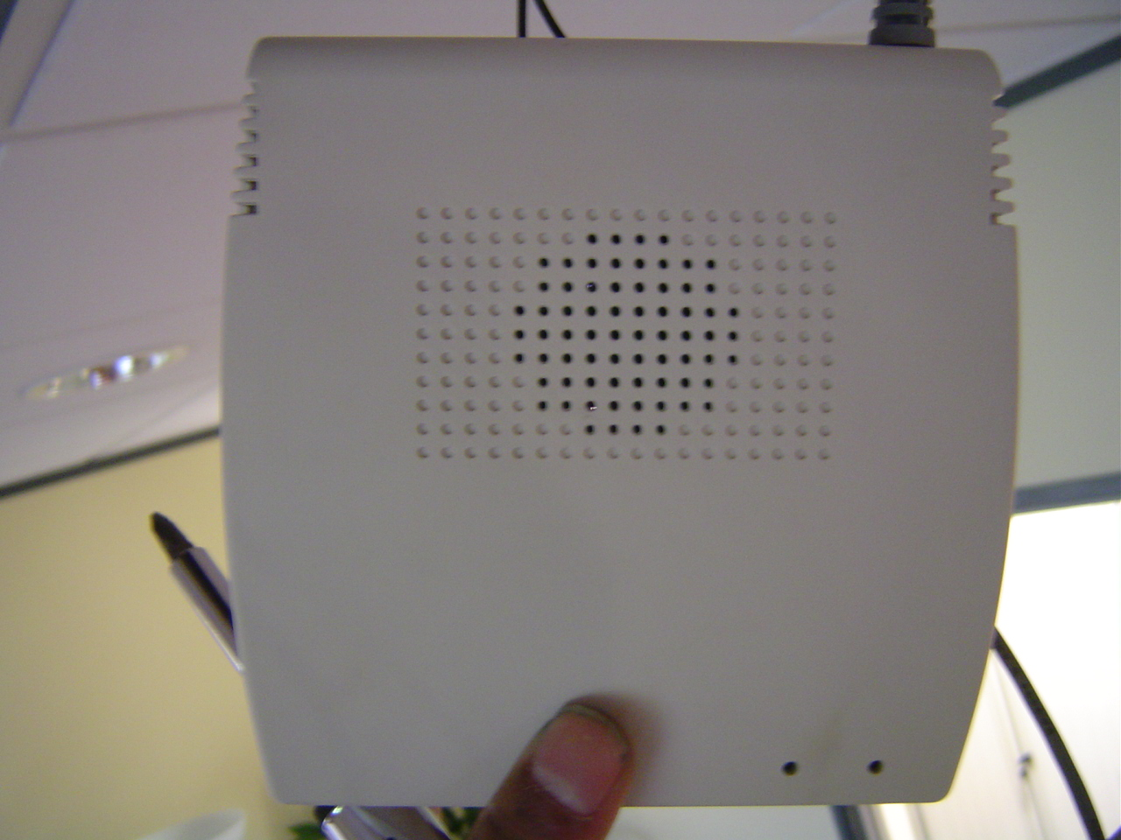
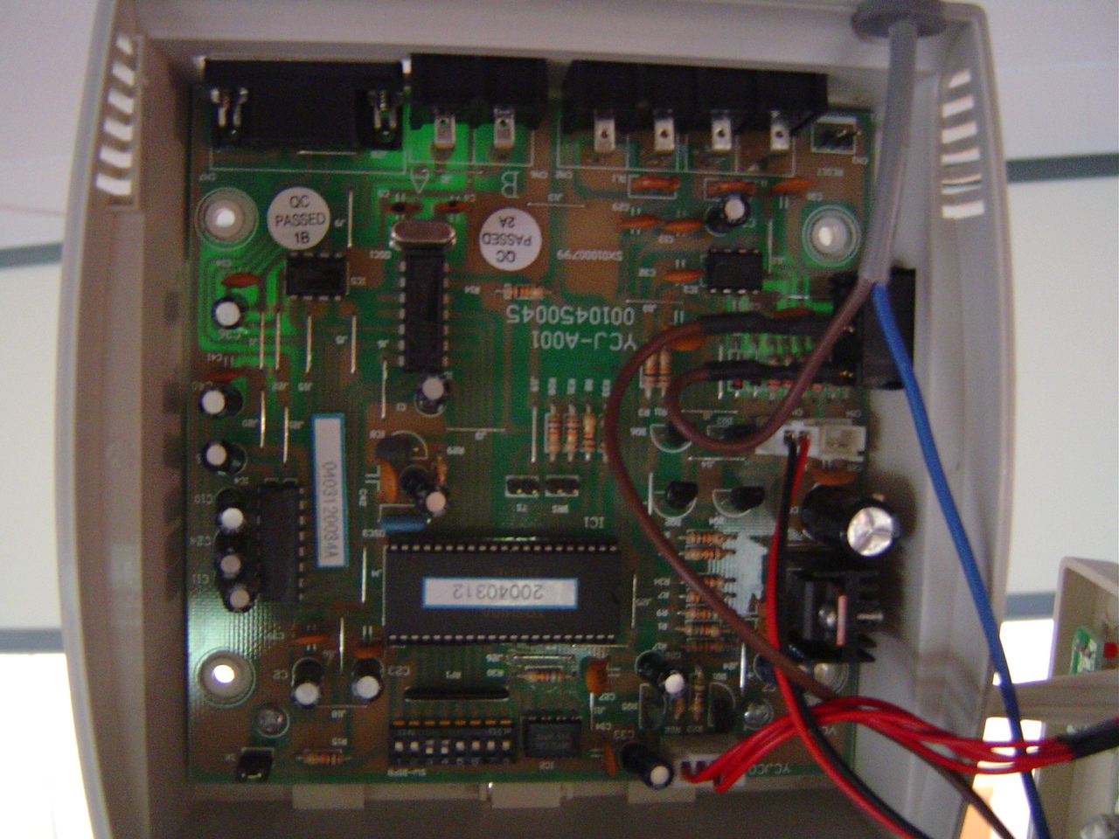

Stardard detector YCJ-A001,every standard detector can be connected with two indoor units.
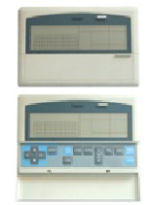Group controller YCZ-A001
Group controller installation wiring diagram
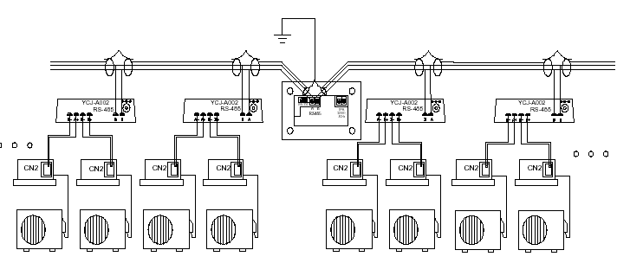
step 1: install wire from indoor PCB (A,B) to detector port(A+,A- or B+,B-)
step 2: install wire from detector (A,B) to group controller (A,B)
step 3: set detector address with dip 1-7:
Dip switch（1- ON，0-OFF） |  |  |  |  |  |  | Address number
No.7 | No.6 | No.5 | No.4 | No.3 | No.2 | No.1 | Address number
0 | 0 | 0 | 0 | 0 | 0 | 0 | 1-1
0 | 0 | 0 | 0 | 0 | 0 | 1 | 1-2
0 | 0 | 0 | 0 | 0 | 1 | 0 | 1-3
0 | 0 | 0 | 0 | 0 | 1 | 1 | 1-4
0 | 0 | 0 | 0 | 1 | 0 | 0 | 1-5
0 | 0 | 0 | 0 | 1 | 0 | 1 | 1-6
……

